**READ ME**

**Idea for deciding if a region is in a location: -**

* **First, we add the regions and score them.**
* **Nest we test it by adding locations**
* **With the latitude and longitude of the location, I calculate the distance to each point in the database in terms of law of cosines. In a general scenario when we have lot of entries this is not a good thing as it might reduce efficiency. However, in this case since our entries are limited, we can with little loss in efficiency.**
* **The distances are stored in a list which is then sorted in ascending order.**
* **From this we can pick the nearest location.**
* **For finding if it exists in a region already in db, I used the search field’s data to separate out state and country. These were then checked with the entries in the db.**
* **Cases: -**

1. **If the location already exists in the db:-**
   1. **Cumulative score should include that region’s score. If one of its containing region is there in db, it should contain that as well.**
   2. **If location exists and no regions, the score is of the location’s.**
2. **If location is not in db nor its regions are in db:-**
   1. **Score should be 0 indicating it is not inside the region.**

**Steps:-**

1. Add Regions at

http://127.0.0.1:8000/location/

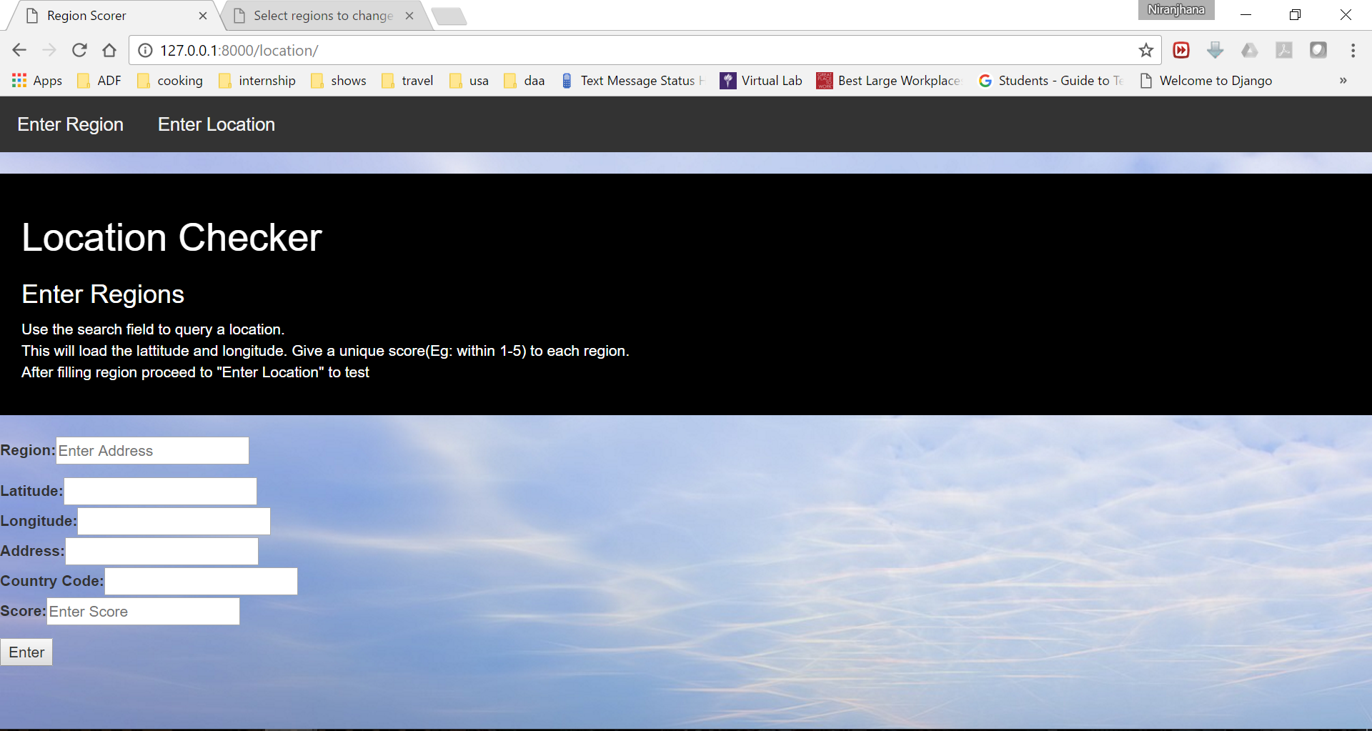

1. 7 regions in

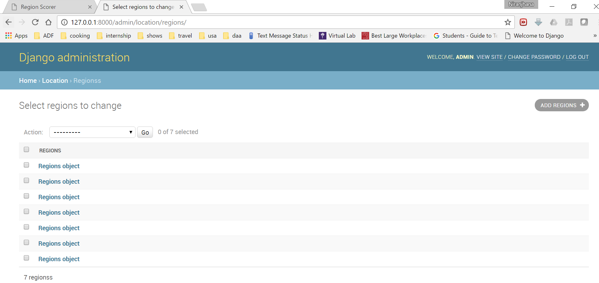

1. Enter location at http://127.0.0.1:8000/location/check/

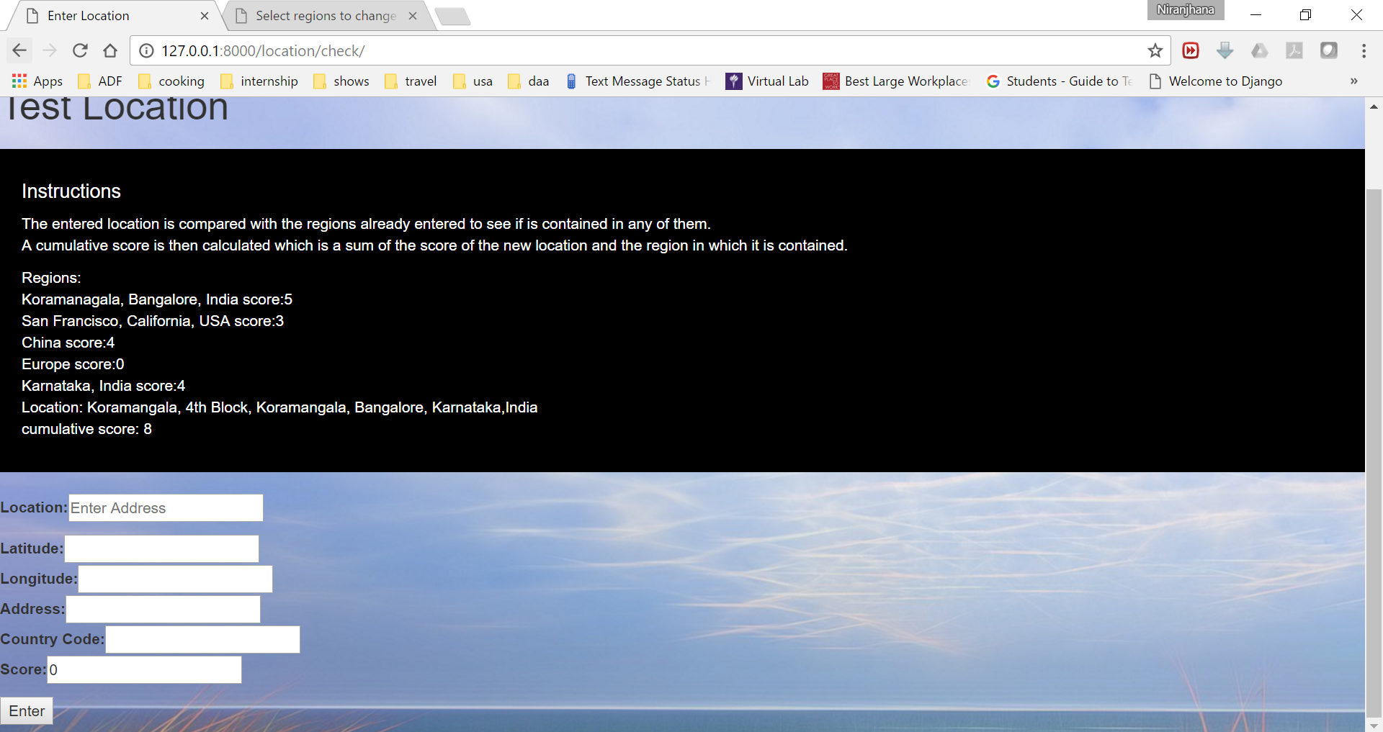

1. Testing Koramangala. The Regions tables contains Koramagala wth score 2 and Karnataka with 6:- output should be 8.

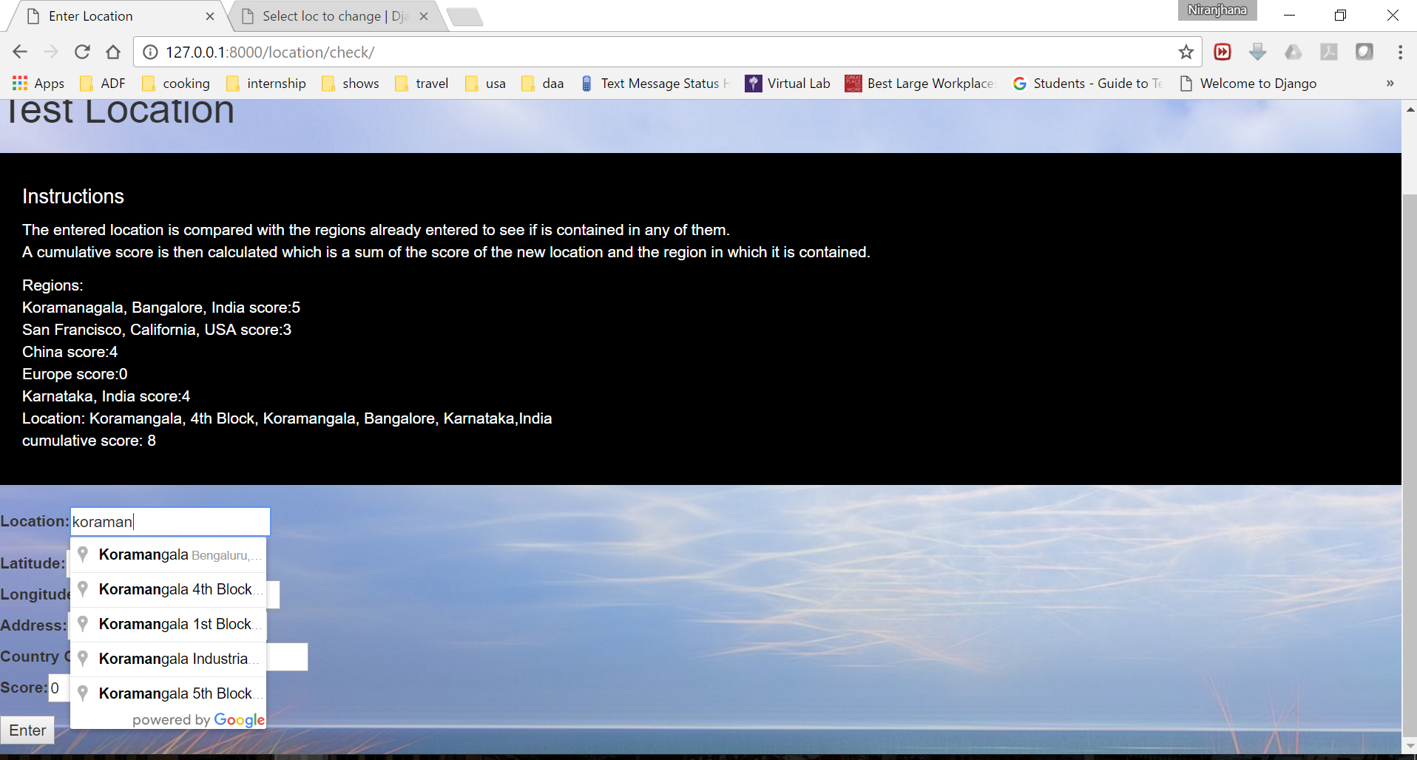

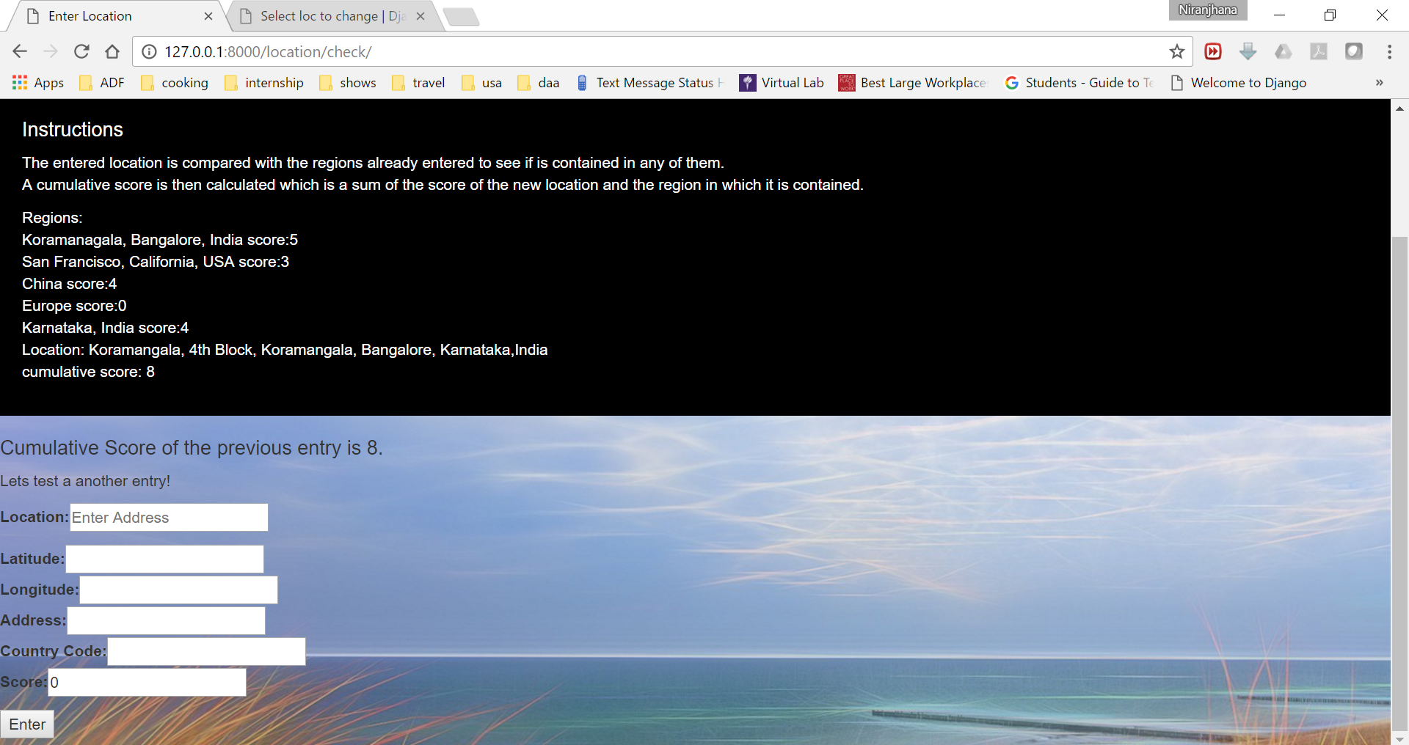

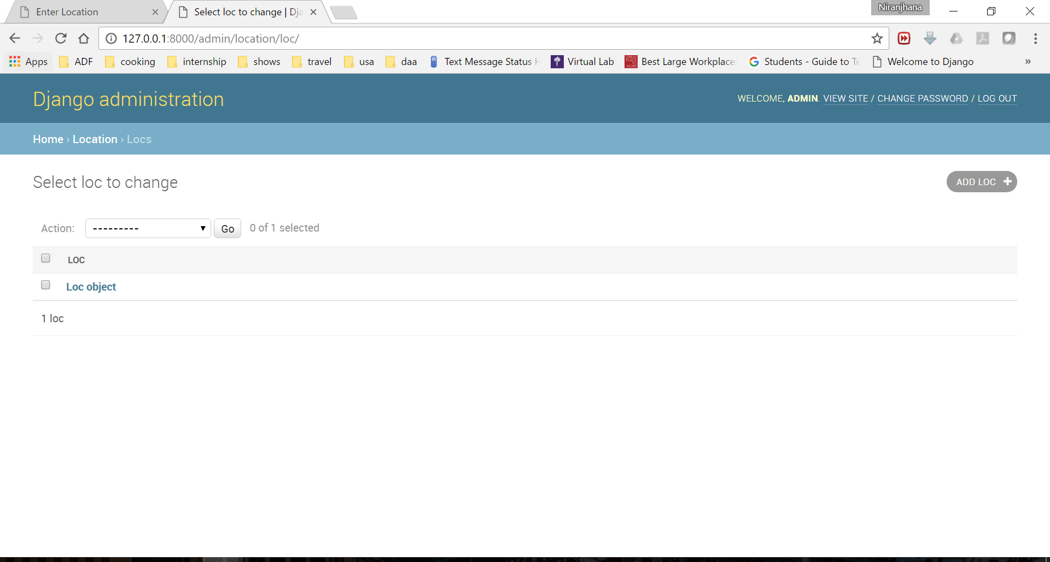

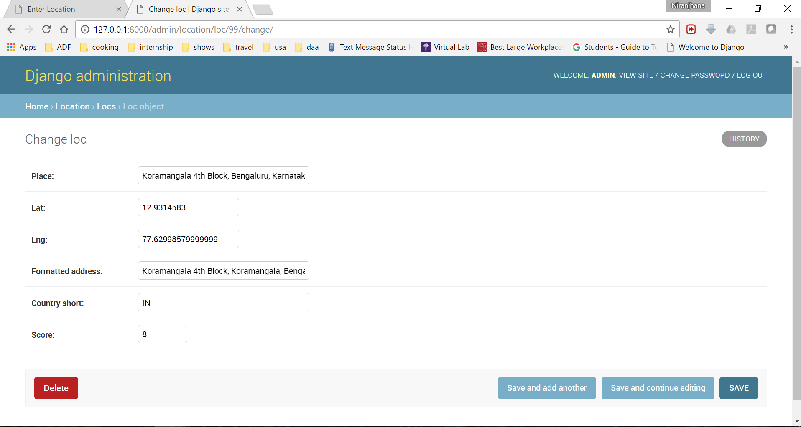

Cases where it will return 0:-

New York is not a region in the database. Newark is. I have made an approximation on the distance obtained after performing the law of cosines on the latitude and longitude. It should return 0.

India is not in the db. However, Karnataka and Koramangala are. However, India is not inside any of these regions. On the contrary, there regions are inside India. This case also it will return 0.

Entries in Loc Table.

